Step’s for how to use it.

STEP 1:-

1. If you are already registered on this website then you can be logged in with the help of your email and password.
2. If you’re not registered then you click on the register Button.

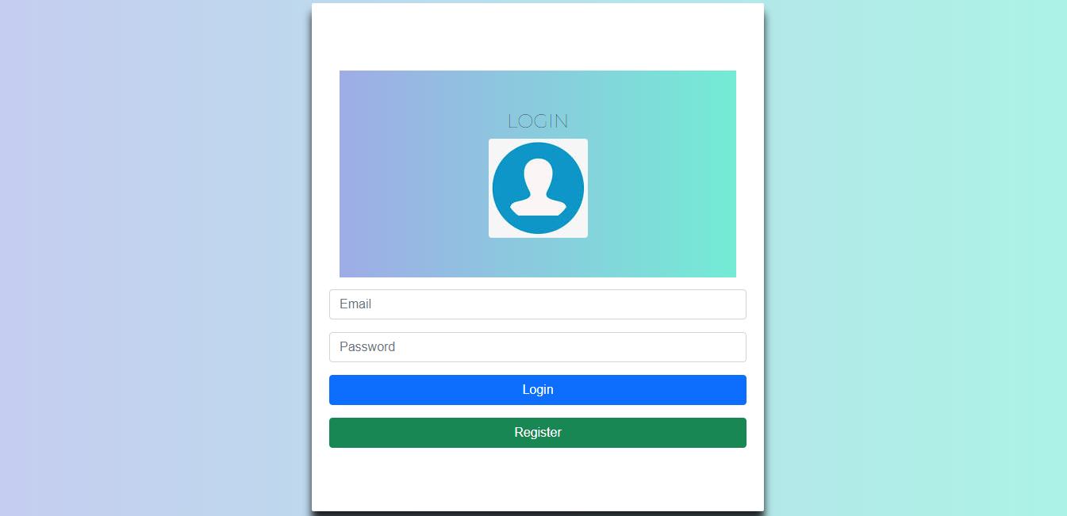

STEP 2:-

1. If you registered click already Sign up link.
2. After clicking on the register button you will come to the registration page.
3. And this page you will fill in your registration (validation) data like **NAME, EMAIL, PHONE NUMBER, PASSWORD, and CONFIRM PASSWORD**.
4. After feeling for click on the Signup page.

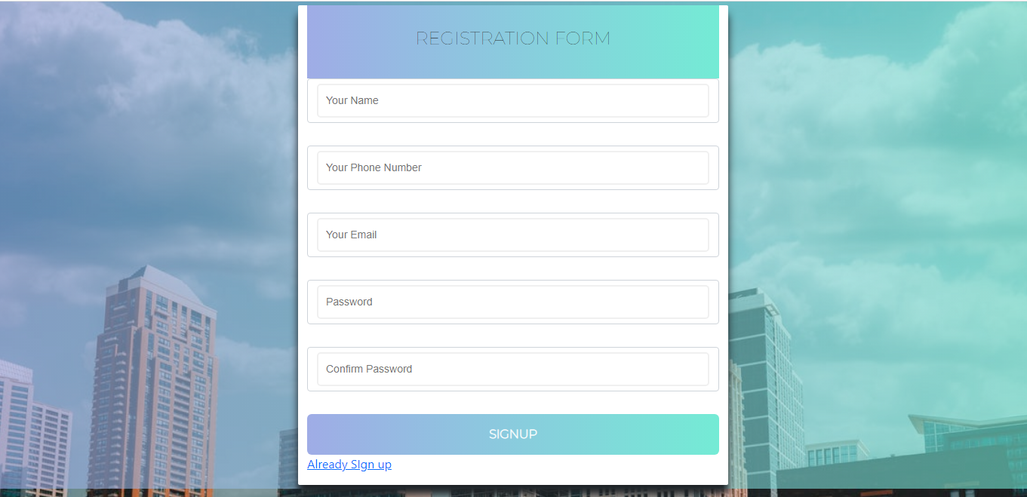

STEP 3:-

1. After complete registration comes back to the login page.
2. And fill email id and password and click on the login button.
3. It will show you the User Details page and a table.
4. This table shows the registered user’s basic information.
5. And Inside the table, we can also do some things like edit and delete.

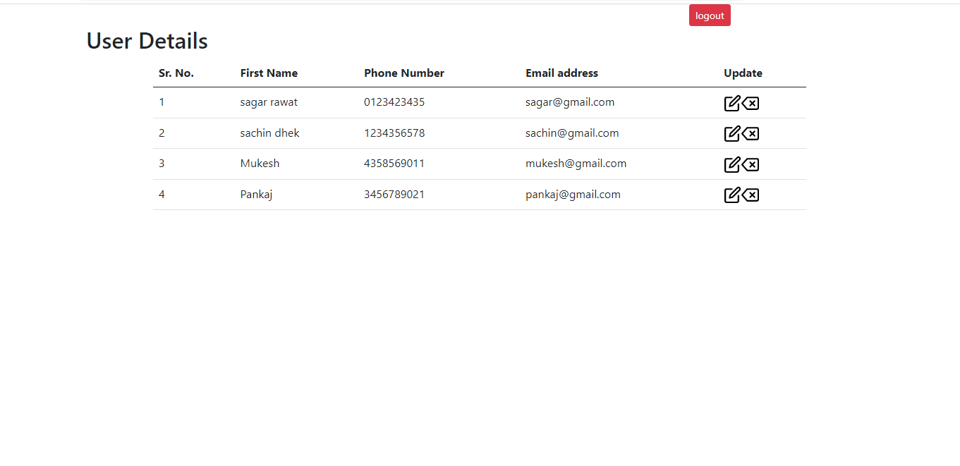

STEP 4:-

1. In the update column first icon is edit.
2. For use of this icon we update our user details.

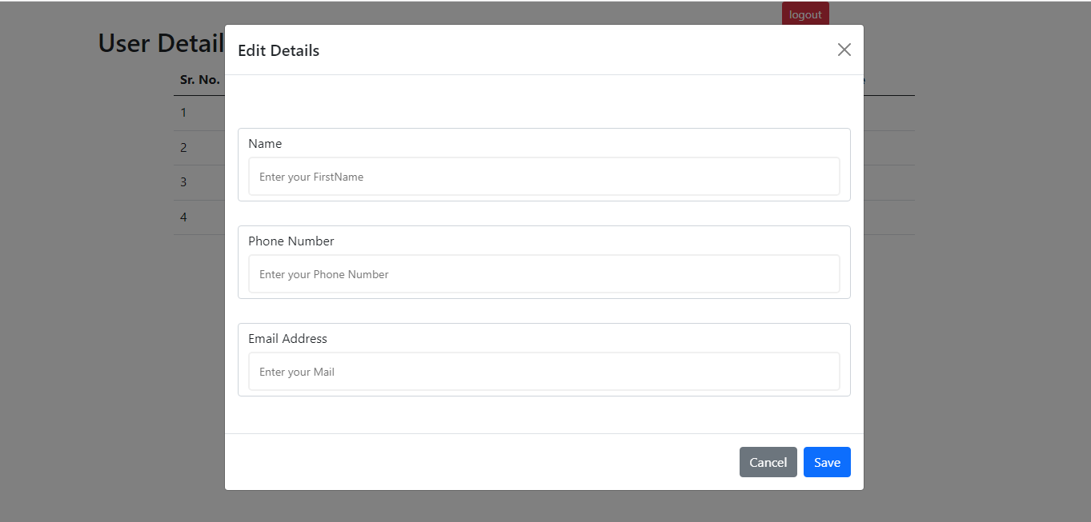

STEP 3:-

1. Or update column second icon is deleted.
2. Delete icon is used to remove a row.

